**Assignment 5**

**Problem Statement:** Text identification using OpenCV, Tesseract (OCR) and deep neural network

**Library:**

This project utilizes the following libraries:

1. OpenCV (cv2): Used for reading, modifying, and displaying images, as well as enhancing them for better text detection.
2. Numpy: Supports efficient numerical operations, including array manipulations on images.
3. Pytesseract: A Python wrapper for the Tesseract OCR engine, allowing easy text extraction from images.
4. Tesseract-OCR: A powerful OCR engine that can recognize text in multiple languages from images.
5. Colab-specific utilities: For uploading files and displaying images within the Colab environment.

**Theory:**

The process of text identification from images involves two major components: image preprocessing and text recognition.

**1. Image Preprocessing**

Image preprocessing is a crucial step in improving the quality of an image before performing Optical Character Recognition (OCR). In this phase, the raw image undergoes various transformations to enhance text features and suppress noise or irrelevant parts of the image. OpenCV provides several tools to perform these operations efficiently. Here’s a detailed breakdown of some key preprocessing techniques:

**a. Grayscale Conversion**

Grayscale conversion is often the first step in image preprocessing. It simplifies the image by reducing its complexity—removing the color channels and converting it into a single-channel image where each pixel represents intensity on a scale from black to white. Since OCR is concerned with shapes (characters), color information is typically unnecessary. Grayscale images contain values ranging from 0 (black) to 255 (white), which makes it easier to apply further image processing techniques.

**b. Noise Removal**

Noise in an image can come from various sources, such as camera imperfections, lighting conditions, or compression artifacts. Noise removal is necessary to improve OCR performance by ensuring that extraneous details do not interfere with text detection. One common technique is **Gaussian Blurring**, which smooths the image by averaging pixel values in a small neighborhood, thus reducing noise.

**c. Thresholding**

Thresholding converts a grayscale image into a binary image, where pixel values are set to either black or white based on a threshold value. This is useful for enhancing the contrast between text (usually dark) and the background (usually light). There are various types of thresholding, but **adaptive thresholding** is especially useful for images with varying lighting conditions across the scene.

**d. Morphological Operations**

Morphological transformations like dilation and erosion are often applied to further refine text areas. **Dilation** enlarges the white regions (text) in a binary image, making text more prominent, while **erosion** shrinks them to remove small noise.

**e. Edge Detection**

Detecting the edges of text can help in localizing and segmenting the text regions in an image. The **Canny edge detector** is one of the most popular methods used in image processing for edge detection.

**2. Optical Character Recognition (OCR)**

OCR converts images of text into machine-readable text. Tesseract is a powerful OCR engine combining traditional algorithms with deep learning.

a. How Tesseract Works

* **Segmentation**: Breaks the image into lines, words, and characters using connected-component analysis.
* **Character Recognition**: A deep neural network classifies characters based on shape.
* **Language Model**: Uses context to correct misrecognized characters.

**b. Limitations of Tesseract**

* Struggles with handwriting and noisy/low-quality images.
* Varies in accuracy based on language, fonts, and image quality.

**c. Neural Network Use**

Recent versions use LSTM networks for better accuracy in recognizing complex text and handling multiple languages and fonts. This improves predictions in challenging environments.

**Methodology:**

1. Image Upload: The user uploads an image containing text (e.g., scanned documents, signs, etc.).
2. Image Preprocessing:
   * Convert the image to grayscale using OpenCV.
   * Apply Gaussian blur to remove noise.
   * Use adaptive thresholding to highlight text areas.
3. Text Detection: Using the Tesseract OCR engine, the preprocessed image is scanned, and regions containing text are identified.
4. Text Extraction: The identified text is extracted and can be printed or stored in a file for further analysis.
5. Display Results: The text regions are highlighted in the image using bounding boxes, and the recognized text is displayed.

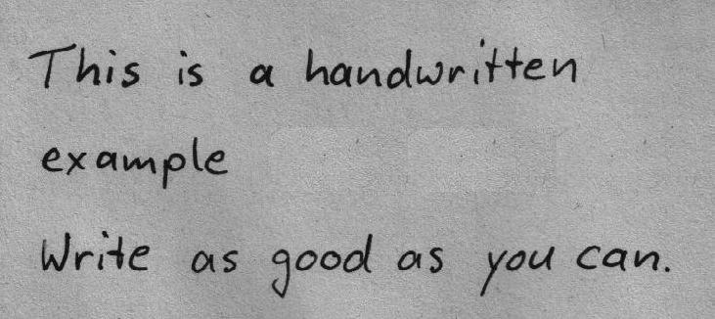

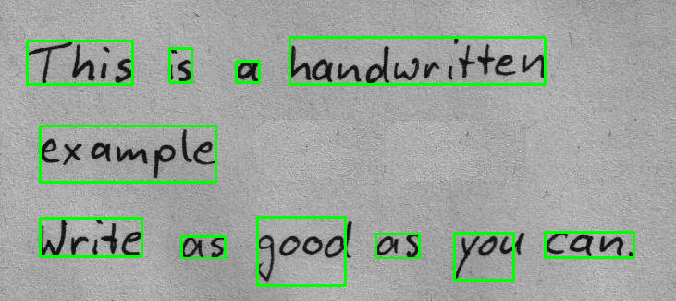

**Advantages:**

1. Automated Text Recognition: The system efficiently extracts text from images without requiring manual intervention, making it scalable for large datasets.
2. Accuracy: By combining OpenCV’s image preprocessing with Tesseract’s deep learning models, the system achieves a high level of accuracy, especially with well-preprocessed images.
3. Flexibility: Tesseract supports multiple languages and works on various types of images, including scanned documents, photographs of signs, etc.

**Disadvantages:**

1. Noise Sensitivity: Tesseract's performance degrades with low-quality images, excessive noise, or complex backgrounds.
2. Complex Preprocessing: For challenging images (e.g., with reflections or distortions), more sophisticated preprocessing is required, which may involve additional coding effort.
3. Limited Handwriting Recognition: Tesseract is not optimized for handwriting recognition, which could limit its effectiveness in certain applications.

**Conclusion:**

The combination of OpenCV and Tesseract offers a strong solution for text extraction, using advanced image processing and neural networks for high OCR accuracy. However, image quality and preprocessing are critical for optimal performance. While effective for many tasks, the system struggles with noisy images and handwriting, requiring improvements for specific cases.